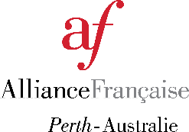

Nomination for membership of the Board of the Alliance Française de Perth
(to be submitted no later than Monday 8 June 2026)
Family name:
First name:
Year of commencement of current term as Board member (if applicable):
Member of the AF: Yes / No (circle)

Please address the following points (no more than 75 words for each answer):

What background experience do you have for a Board role (i.e. governance, finance, legal, commercial, marketing, education, cultural)?

What skillsets do you possess to contribute to the good operation of the Board?

What is your availability to fulfil your obligations as a Board member?
(The Board meets bi-monthly and members are expected to attend at least five meetings annually (in person or via teleconference), participate in sub-committees relevant to members’ skillsets. In addition, you are expected to attend several Alliance Française de Perth cultural and social events during the year.)

N.B. If you are a Board member seeking re-election, please advise how many of the six meetings you attended (in person or via teleconference) since the last AGM.

How will you contribute to the aims and growth of Alliance Française de Perth?

Signed: Date:

Guidelines are available on the Department of Commerce of WA website: http://www.commerce.wa.gov.au/consumer-protection/inc-guide-and-associations-online

Tél. +61 (08) 9386 7921
75 Broadway, Nedlands, WA 6009 site : www.afperth.com.au - courriel : info@afperth.com.au
ABN: 78 073863076

